**Discussion 1**

What is the output of the following Python program?

value = 6

if value % 2 == 0:

print("first", value)

elif value % 3 == 0:

print("second", value)

## This prints out “first, 6”

while value <= 9:

value = value + 1

if value == 8:

continue

else:

pass

print ("third", value)

else:

print ("fourth", value)

print("fifth", value)

**Discussion 2**

The following program calculates the number of input strings with letter ‘a’, and end the program when the input string is “####”. Here is an expected sample run:

***Sample :***

enter a string (enter #### to stop): apple

enter a string (enter #### to stop): banana

enter a string (enter #### to stop): strawberry

enter a string (enter #### to stop): book

enter a string (enter #### to stop): ####

3 strings with letter 'a'

count = 0

while True:

str = input("enter a string (enter #### to stop): ")

if str == “####”:

break

for letter in str:

if letter == “a”

count +=1

print(count , "strings with letter 'a'")

There are some errors in the above program. Please indicate where the errors are and how to correct them.

**Discussion 3**

Write a simple Python program to implement the Pseudocode of FizzBuzz problem in discussion #1.

## Question 3

# counter = 0

# while counter < 20:

# counter += 1

# if counter % 3 == 0:

# print("Fizz")

# elif counter % 5 == 0:

# print("Buzz")

# elif counter % 5 == 0 and counter % 3 == 0:

# print("FizzBuzz")

# else:

# print(counter)

**Discussion 4**

Write a Python program that reads an integer from the user, which is the width of the pattern below, and then prints out the pattern. Suggestion: use nested **for** loops. Hint: **print("*",end="")**.

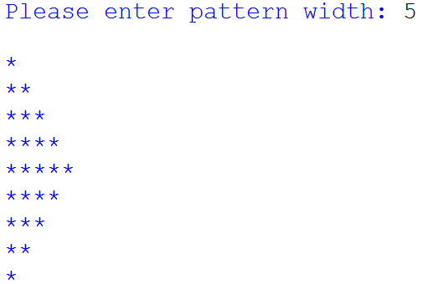

Further discussion: Is it possible to use **for** only twice? Or even once? (of course no **while**)